**INFORMATION**

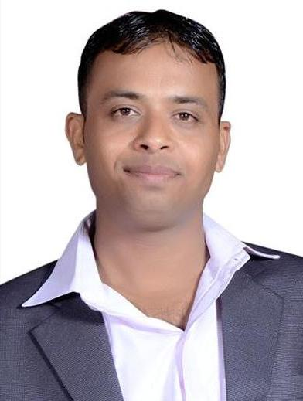

**NAME: Dilip Kumar Sharma**

**PASSPORT SIZE PIC:**

**Highest Qualification: M.A., MCA**

**Designation: Lab Technician**

**LAB No. Assigned: CP-20 (C Block)**

**Email Id: dilipkumarsharma.cse@jecrc.ac.in**

**Experience: 10 Years**